- Bookwork but not just reproducing a section of the lecture notes: will accept answers based around the following information given in lectures.
(i) point defects
vacancies, interstitials, Schottky defects, Frenkel defects
evidence:
finite electrical conductivity in any material, ionic conductivity in insulators, optical properties: colour centres
(ii) line defects
edge and screw dislocations
evidence:
theoretical strength much greater than measured strength
plastic deformation ie irreversible change in shape
crystal growth nucleated where screw dislocations penetrate surface
(iii) plane defects
grain boundaries, twin boundaries
evidence:
bubble rafts, broadening of Xray scattering dots, existence of micro-crystallites
(iv) volume defects
voids
evidence:
Scanning tunneling microscope pictures
[10]

(b) Bookwork

Schottky defect eg in NaCl: a cation (Na⁺) and anion (Cl⁻) vacancy pair

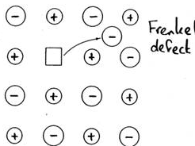
Frenkel defect: a vacancy and interstitial pair

[2]

(c) Set as a problem with solutions provided.
In a Schottky defect, to maintain charge neutrality, for each cation vacancy, there is an anion vacancy. The number of ways to pick n_{S} cation vacancies from N cation sites is N!/[(N − n_{S})!n_{S}!], which is equal to the number of ways to pick n_{S} anion vacancies from N anion sites. Therefore configurational entropy associated with the vacancies
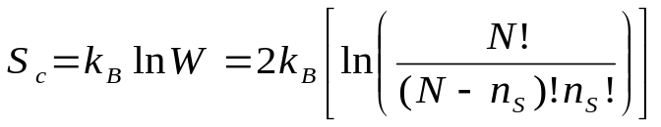
Using the Stirling approximation,
The free energy,
where G₀ is the free energy of a perfect solid.
At equilibrium,
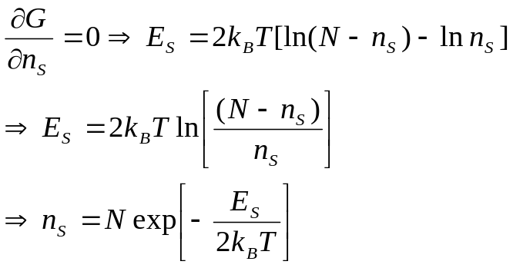
[4]
(d) Not seen before
(i) Assumptions:
Schottky defects dominate
Quenching freezes in Schottky defects
Neglect contribution to change in density from change in unit cell dimensions due to atoms relaxing around atoms.
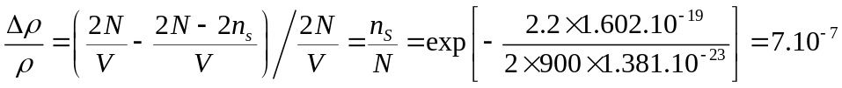 [2]
(ii) A unit cell of the rock salt structure with lattice constant a₀ contains 8/a₀³ atoms per volume. Relative change in volume of unit cell with vacancy (interstitial), if Δa_{V} (Δa_{I}) is change in the lattice constant due to the vacancy (interstitial), assuming
Δa_{V} << a_{0,} Δa_{I} << a₀
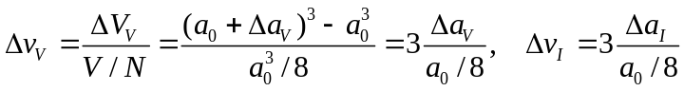
There are n_{F} Frenkel defects and each Frenkel defect is a vacancy – interstitial pair, so
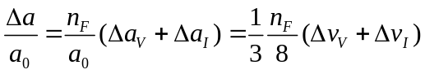 [2]

2. (a) Bookwork
Relaxation occurs at many close-packed metal surfaces.
Think of bulk metal as a series of charge neutral Wigner-Seitz cells.
Each cell contains conduction electrons which screen +ve ion cores.
Net electrostatic forces are attractive leading to metal bonding.
At a surface, the conduction electrons can lower their kinetic energy by moving inwards.
The net electrostatic force on the outermost layer is inwards so get relaxation.
Relaxation usually inwards, though sometimes oscillates over several layers.
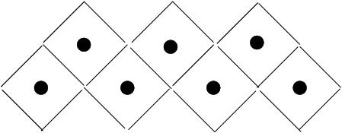
Bulk

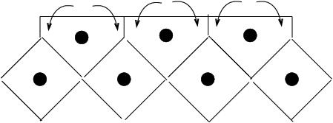
Surface
Electrons move
to minimise energy

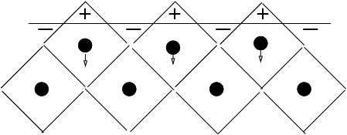
Net electrostatic field
moves ions inward
[4]
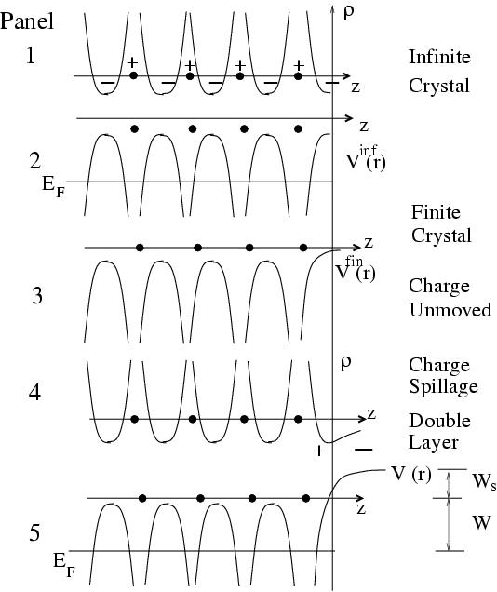
Panel 1 Charge density ρ_{inf}(r) corresponding to V_{inf}(r)

Panel 2 V_{inf}(r) .
At T = 0 K, electrons occupy states up to the Fermi energy.

Panel 3 V_{fin}(r)

Panel 4 Charge density ρ_{fin}(r)
corresponding to V_{fin}(r) with additional charge spillage creating a double layer.

Panel 5 V_{fin}(r) with additional dipole potential W_{s} from the double layer.

[6]
(c) Not seen before. Hopefully students will get a hint from parts (a) and (b). They have been told in lectures how adsorbates can create a dipole that opposes the dipole from charge spillage and thus reduce the workfunction. They have also been shown how a reduction in the workfunction can lead to an enhanced sticking probability.
Unrelaxed electron and ion configuration at step.
Electrons move to minimise energy.

+
-
-
+
Dipoles are created as shown.

The dipole at the step edge due to smoothing of the electron density points in the opposite direction to the dipole due to charge spillage so the work function at the step edge is reduced. Thus electrons from the substrate are extracted more easily and so bonding with adsorbed atoms is enhanced. [4]
d(i) Done as problem with solution provided.
a_{b} = b_{b} = a₀/√2, γ = 120º
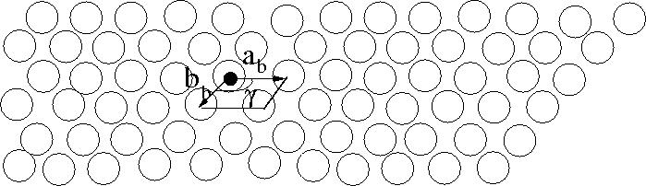
[3]
d(ii) Intended as a challenge for the best students. They have seen the Ag(111)√3×√3R30º structure in a problem with solution provided.
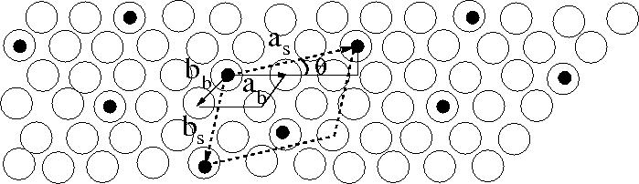
a_{s}² = (2.5)²a_{b}² + 0.75a_{b}² = 7a_{b}². Similarly, b_{s}² = 7b_{b}².
tan(θ) = (0.5√3)/(2.5) = 0.35 so θ = 19.1º [3]

